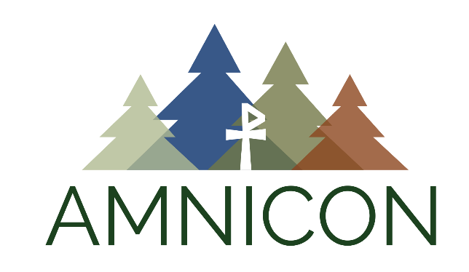
Adult Leader FAQ’s
(What's my role?)

Being an adult leader on a trip with youth can be a very exciting and challenging time. Going on a guided trip through a camp offers many advantages for you as an adult. Since you are not "in charge" of the experience, you are able to get to know the youth on a different level. You live alongside the youth and take part in the Amnicon experience together. You probably have some questions about roles and expectations. Please read through the following information and if you have further questions please contact us at (715) 364-2602 or campamnicon@usa.net.

What will I be Doing?
You will take part in all aspects of trail life. That includes; paddling, carrying packs, putting up tents, gathering firewood, sleeping in tents, cooking over the campfire, doing dishes, hiking, singing, campfire discussions and generally having fun and being a part of the community!

What are my Responsibilities?
Get to know the youth on the trip. Encourage youth to follow safety rules and follow them yourself. Be a positive role model in attitude and action. Support the guide/counselor. Participate in all aspects of community and trail life. Enjoy yourself!

Who makes the Decisions?
For reasons of safety and liability, Amnicon guide/counselors have been thoroughly trained to lead all aspects of the trip and make safety judgments where needed. As an American Camping Association Accredited camp, we follow specific guidelines and trails procedures. Occasionally, some adults who are very experienced campers find that we do things in a different way from the way they are used to—for example, Amnicon has specific safety procedures for using a hatchet while on the trail. We ask that all adults be flexible and follow Amnicon procedures on this trip. Please support the Amnicon staff and note that their judgment on all safety decisions must be respected.

Do I have Program or Devotional Responsibilities?
Unless other arrangements have been made with the group's organizer, Amnicon staff will lead all programmed activities, including bible study and devotions. We welcome and encourage your participation. If your group does not wish to use the Bible study please let us know prior to your trip to Amnicon. If you wish to take active leadership in the program, please make your desires known to your guide as soon as possible after arriving.

